Study on an existing working model of Microwave oven.

A **microwave oven** (commonly referred to as a **microwave**) is an electric [oven](https://en.wikipedia.org/wiki/Oven) that heats and cooks food by exposing it to [electromagnetic radiation](https://en.wikipedia.org/wiki/Electromagnetic_spectrum) in the [microwave](https://en.wikipedia.org/wiki/Microwave) [frequency](https://en.wikipedia.org/wiki/Frequency) range.[[1]](https://en.wikipedia.org/wiki/Microwave_oven#cite_note-1) This induces [polar molecules](https://en.wikipedia.org/wiki/Dipole#Molecular_dipoles) in the food to rotate and produce [thermal energy](https://en.wikipedia.org/wiki/Thermal_energy) in a process known as [dielectric heating](https://en.wikipedia.org/wiki/Dielectric_heating). Microwave ovens heat foods quickly and efficiently because excitation is fairly uniform in the outer 25–38 mm of a homogeneous, high water content food item.



BLOCK DIAGRAM:

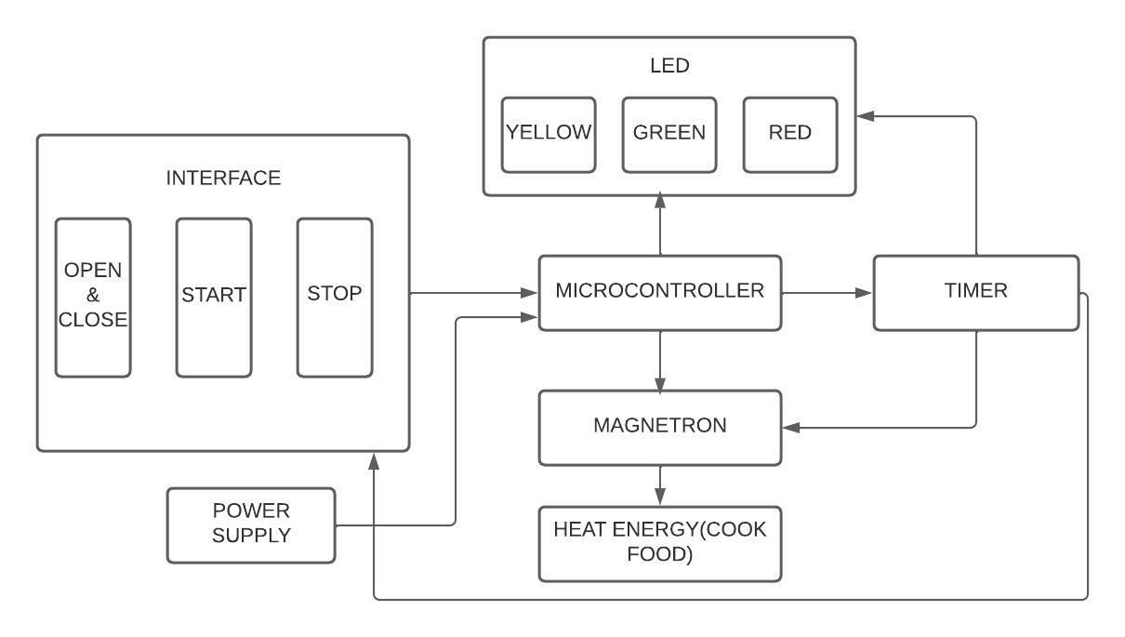

**Requirements:**

**High level requirements:**

1. Interface with Keypad.
2. Emergency stop should be there.
3. Timer Should be there.
4. Continuously it should cook for the given interval of time.
5. Cost should be less than RS 8000

**Low level requirements:**

1. Movable.
2. Lite weight.
3. Indicators.
4. Compact.